Kubernate Deployment Rollback and Rollout

- A Kubernetes Deployment manages ReplicaSets, and ReplicaSets manage Pods. Rollout creates new ReplicaSets and Pods, while rollback reactivates old ReplicaSets for fast recovery with zero downtime.
- Deployment → ReplicaSet → Pods
- Update Flow: Deployment update → New ReplicaSet → New Pods → Old Pods terminated
- Rollback Flow: Rollback command → Old ReplicaSet activated → Old Pods restored → New Pods removed

Step 1:- Creating folder and deployment file
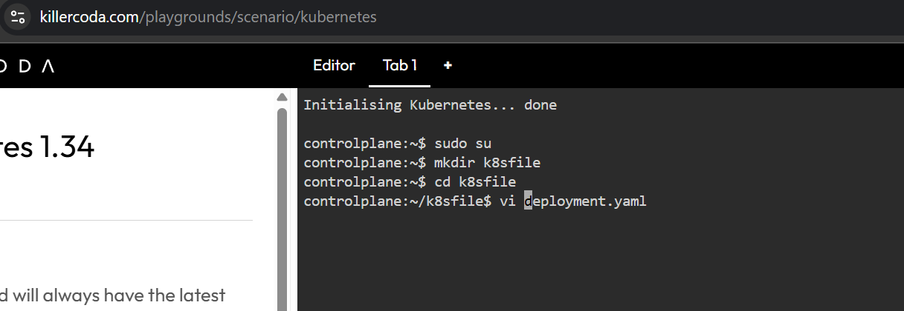

Step 2: Here we create a namespace
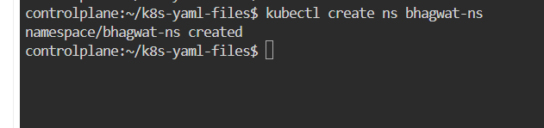

Step 3: Deployment.yaml file in this file version 1 of fitness is created .
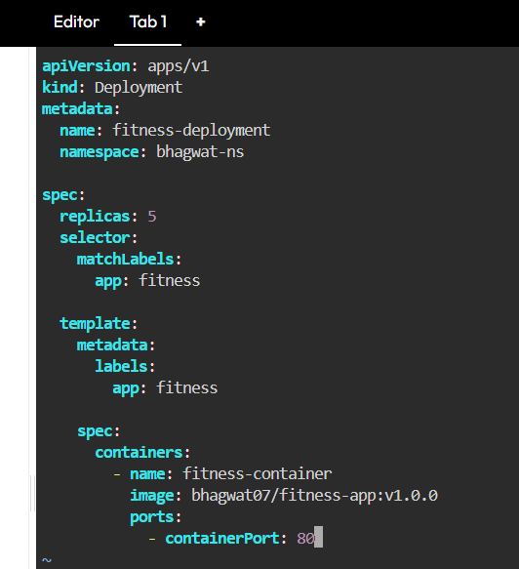

Step 4:We apply the deployment.yaml file and check the pods , replicaset and deployments
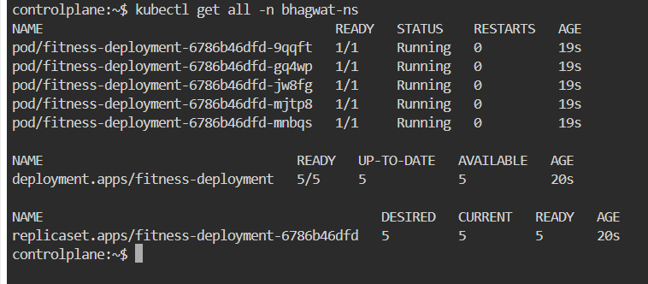

Step 5: New image of fitness app is given and after that it is applied
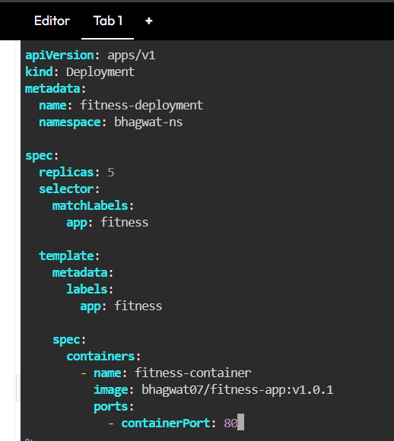

Step 6: check the pods , replicaset and deployments as new pod are created old get deleted new replicaset is also created
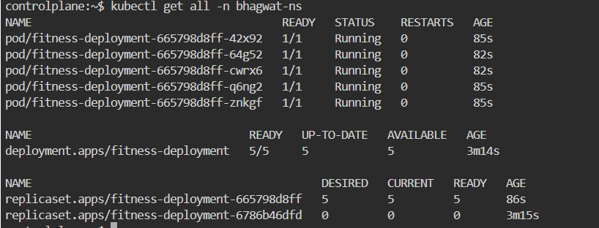

Step 7: Here in description we can check pod is of newer version
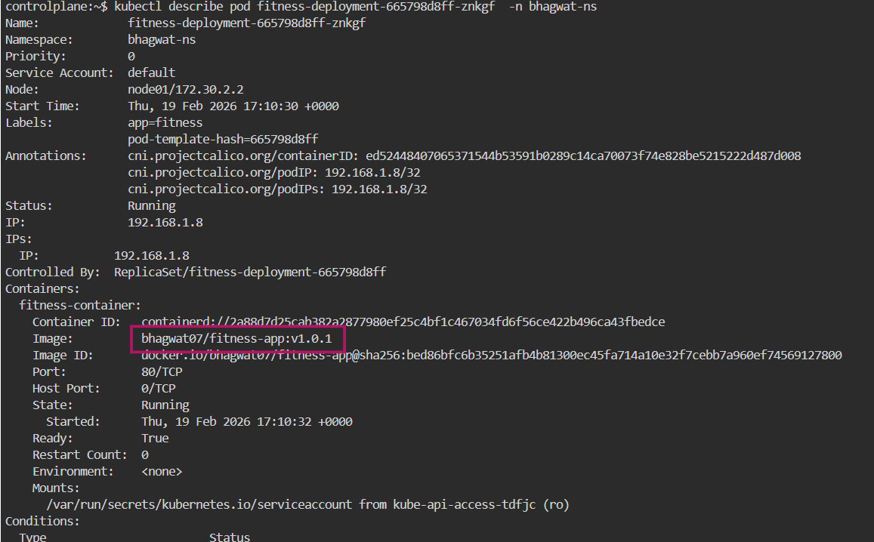

Step 8: We have used rollback command

Step 9: After rollback newer replicas pod get deleted and old replicas pods get generated also number in front of replicaset is changed
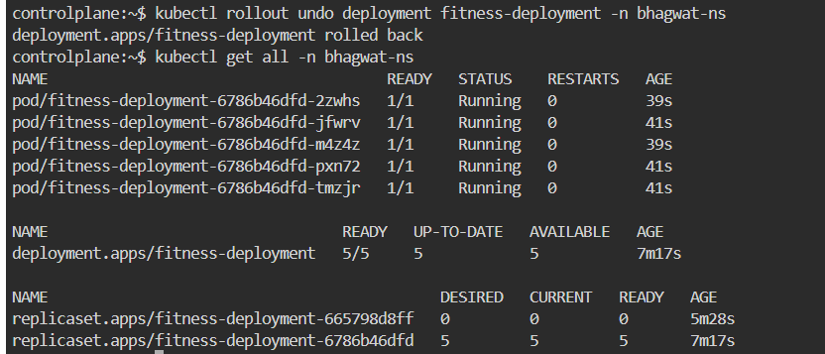

Step 10: Here in description we can check pod is of older version

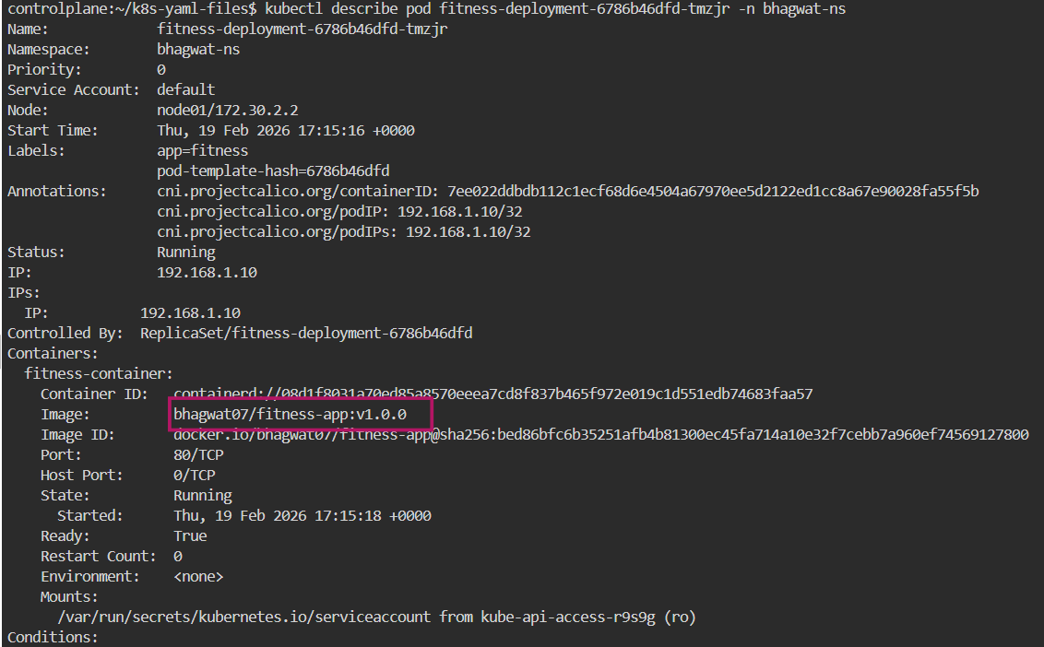

Step 11 : Here we can see status that rolled out is successful
